D latch using Mux and Inverters
Introduction:
Firstly, latch is a sequential circuit which is level triggered. A sequential circuit is a combination of combinational circuit and a feedback loop. It can store previous output as well take present input according to clock/ control signal. A latch is level triggered, i.e. output changes according to the input until the level of control signal does not change. A D latch acts as a transparent latch when control signal is applied, otherwise it holds the previous state.

Truth Table:
D | Y
0 | 0
1 | 1

Truth table seems quiet simple but input appears at output only when, clock signal is applied. If D latch is negatively triggered it acts as transparent latch until the clock signal is low. If it is positively triggered, it acts as transparent latch until clock signal is high. Similarly, we have flip flops which are edge triggered i.e. they read the input at specific edge of clock and rest of the time they hold their previous state.

Circuit Diagram:
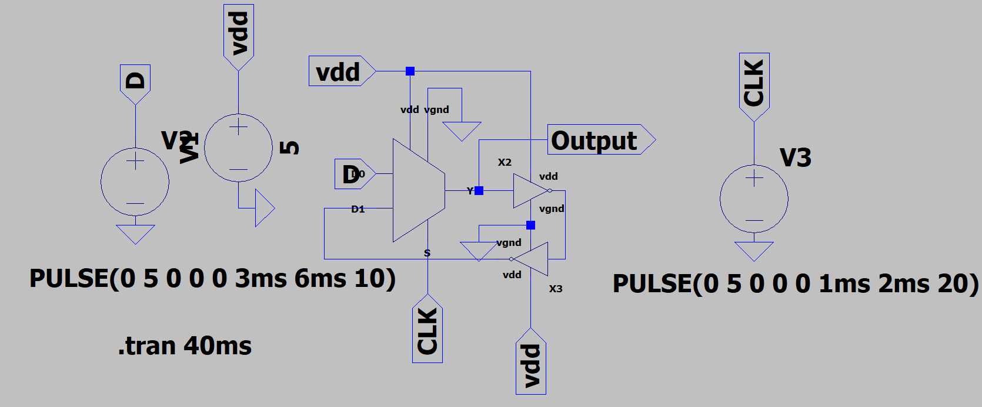

Working:
We have designed a negative level triggered D latch using 2:1 multiplexer and two inverters. Select line of mux is connected to the clock signal. Input signals to mux are D and the feedback provided from combination of two inverters. When the clock signal goes low, D is selected as the output of the mux, hence mux acts as a transparent latch. Feedback loop consists of two inverters which provide the appropriate delay. When the clock signal goes high, feedback loop is selected as output for the mux. Hence, latch holds the previous output.

Simulation Result:
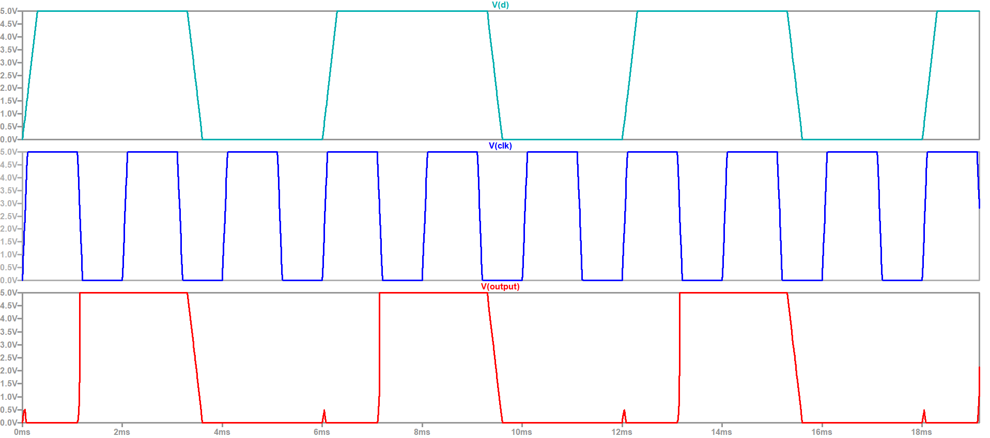
First waveform represents the input D, second represents the input clock signal and third one is the output. Latch follows the D signal until the clock signal is low.
There are small triangles in the output. These are due to the rise and fall times of the signals. D signal has a rise time of 0.3ms. When clock signal transitions from low to high and D signal starts rising, this pulse appears at output because output tries to follow the input but as soon as clock pulse goes high, it output follows it previous state from the feedback.

Author:
MADHUSUDAN

